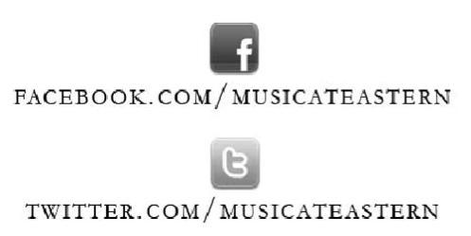

[TITLE or TYPE OF PROGRAM]
(ex: Senior Recital, Junior Recital, etc.)

[Performer’s Name, Instrument/Voice Type]

and

[Additional Performer #1, Instrument/Voice Type]
[Additional Performer #2, Instrument/Voice Type]
[Additional Performer #3, Instrument/Voice Type]

[DAY OF THE WEEK], [MONTH] [DATE], [YEAR]
[TIME]
[VENUE]
Fine Arts Instructional Center
Eastern Connecticut State University

This recital is given in partial fulfillment of the requirements of the Bachelor of Arts in Music with a concentration in Performance.
(Include the above statement only if this is a SENIOR recital)

[FULL NAME] is a student of [INSTRUCTOR’S NAME].

[Brief and appropriate acknowledgements may be included here if you wish.]

Program

[INSERT PROGRAM ORDER HERE]

