Guidelines for Domestic and International Global Field Courses
2024-25 Academic Year


EASTERN CONNECTICUT STATE UNIVERSITY
Global Learning
J. Eugene Smith Library, Room 225
(860) 465 – 0674
Chris Drewry
Global Learning Coordinator

Table of Contents
Introduction and Administrative Processes……………………………………………………………………………….4
Timeline…………………………………………………………………………………………………………………………………….5
Developing Your GFC/Pre-Application Process…………………………………………………………………………..7
- Getting Started
- Travel Service Provider
- Considerations (General, Cultural, Academic, Location/Time of Year, Staffing, Teaching Assistants, Itinerary Selection, Itinerary Modifications, Program Credits, Scheduling, Contact Hours, Site Visits, Unstructured Time, Independent Travel, Lodging, Faculty Travel Costs, Faculty Compensation)
Program Proposal/Application…………………………………………………………………………….…………………..14
- Establishment of Academic Courses
- Budget Development
- Enrollment Targets
Post-Application/Program Approval…………………………………………………………………………………………16
- Course Tuition and Fees
- Scholarships
- Developing a Promotional Flyer
- Additional Promotional Materials
- Developing a Timeline for Students
- Student Application and Enrollment Policy
- Accomodation
- Student Application Process
- Enrollment Process – Academic Courses
- Non-Degree Student Enrollment/Participation
- Collecting of Revenue & Payment to Vendors (Bursar’s Office)
- Cancellation by Eastern due to Low Enrollment
Course Offering …………………………………………………………………………………………………………………...…21
- Pre-Departue Orienation Programs
- Global Learning Participant Release Checklist
- Student Costs
- Payments by Students
- Faculty Use of the Eastern Travel Account
- Termination of Participation in a Global Field Course
- Cancellation by Eastern due to Safety Concerns
- Withdrawal by Students from Travel Program
- Cancellation/Withdrawal by Students – Acadmic Course(s) Associated with a Global Field Course
Travel………………………………………………………………………………………………………………………………….……25
- Transportation to-from Airport
- While Abroad
- Roommate Assignments
- Risk Management (Faculty Concerns, Student Concerns, Faculty: Medical Concerns, Student: Medical Concerns)
Post-Course/Travel……………………………………………………………………………………………………………………29
- Post-Program Student Survey
- Academic Credits
Appendix…………………………………………………………………………………………………………………………………..30
- Planning Resources When Traveling Out of the Country (Safety, Health, Itinerary Planning)

Introduction
This guide informs faculty of policies, regulations, and timelines that govern courses including domestic and international travel. Faculty are required to consult with Global Learning when developing a course.
A Domestic or International Global Field Course at Eastern Connecticut State University is a 1 to 6-week experience carrying Eastern course credit and belonging to a host academic department or collaborating departments. These courses are taught in part or entirely on-site in locations away, by Eastern faculty or a combination of Eastern faculty and faculty/practitioners from a visited institution or host country.
Global Field Courses are an important component of Eastern's mission as a liberal arts university. Global Field Courses promote an understanding of different cultures, reinforce liberal arts learning outcomes, and complement the University's strategic initiatives.

Administrative Processes
Global Learning is charged with responsibility for overseeing specific administrative aspects of Domestic and International Global Field Course offerings. This includes, but is not limited to, building campus support for the Global Field Course programs; facilitating the Global Field Course approval process; developing application and promotional materials; familiarizing faculty with the university support systems such as the offices of the Bursar, Financial Aid, Purchasing and Accounts Payable. Global Learning also provides information relative to risk management; selecting travel service providers; setting up financial accounts; and scholarships. The processes in place have been designed to minimize institutional liability, promote academic integrity, set and collect program fees, and make payments to vendors.
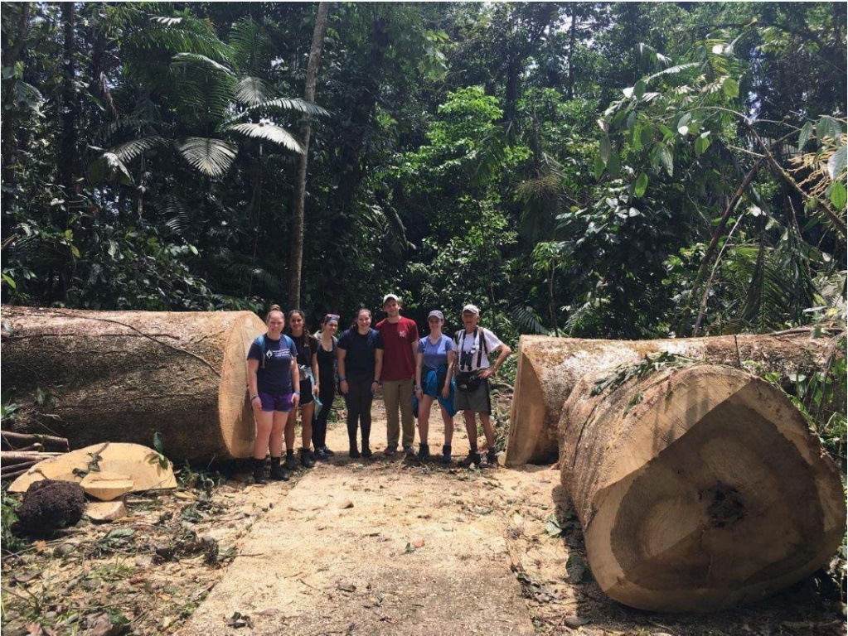

Timeline
Domestic and International Global Field Course programs can be organized in several ways. Scheduling GFCs during the normal scheduling process (1-year in advance) allows time for recruiting students so that the course is likely to fully enroll. Additionally, professor teaching loads need to be coordinated a year in advance for academic department scheduling purposes.
Several timing options are available for scheduling Global Field Courses:
(1) GFC is offered as a Spring semester course in which the domestic or international experience takes place during the summer, following commencement. Students register for the Global Field Course during the Spring semester as part of their course load; engage in pre-trip orientation and lecture sessions during the spring; receive an incomplete grade at the conclusion of the semester; and participate in the travel component of the course.
(2) GFCs can also be offered as a Spring semester course in which the domestic or international experience takes place during the Spring Break in March.
(3) GFC is offered as a Fall semester course in which the domestic or international experience takes place in January during the winter break. Students register for the Global Field Course during the Fall semester as part of their course load; engage in pre-trip orientation and lecture sessions during the semester; receive an incomplete grade at the conclusion of the semester; and then participate in the travel component of the course.
The following timeline is for developing a GFC with spring/summer travel:
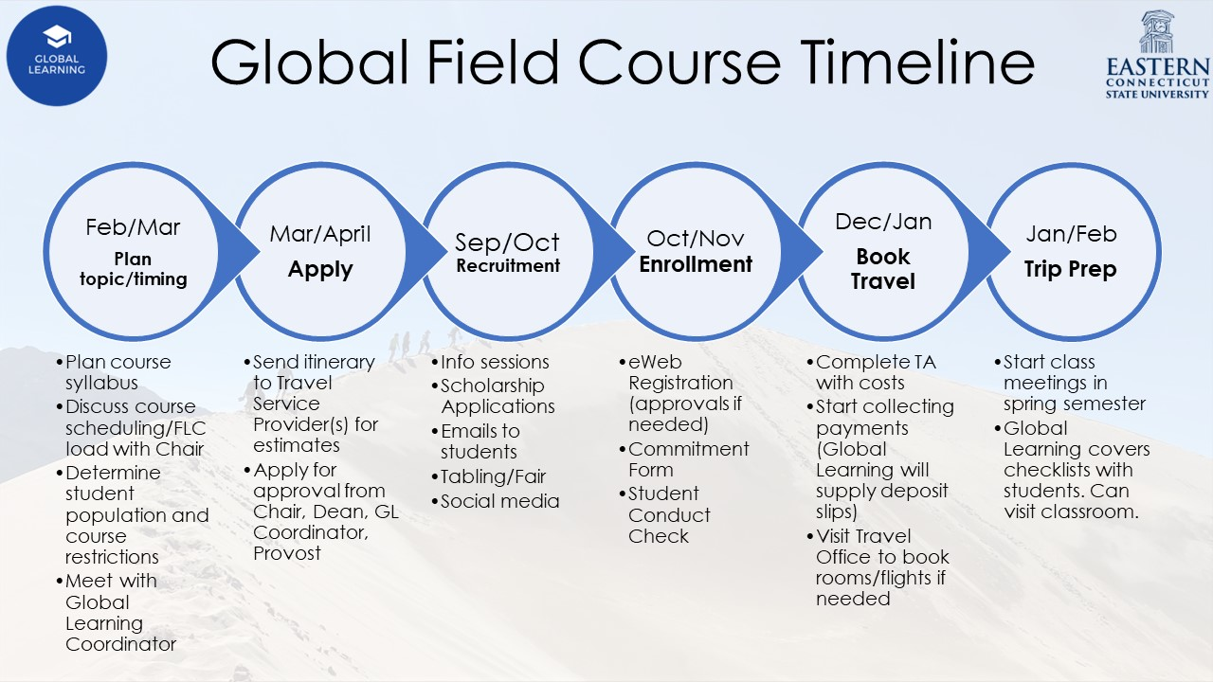
Please note that the Global Field Course Proposal Form must be submitted to Global Learning by May 1. The form includes a draft itinerary, budget, and syllabus. The proposal will then be routed to the appropriate Chair, Dean, Global Learning Coordinator, and Provost. Please leave plenty of time for paperwork to go through the signature process.
If approved, faculty should plan to meet with the Global Learning Coordinator monthly to check-in and discuss the course in the semester prior to the course running.
There are resources for faculty available on the Eastern Global Learning Website, including application materials. Click here to visit the webpage.

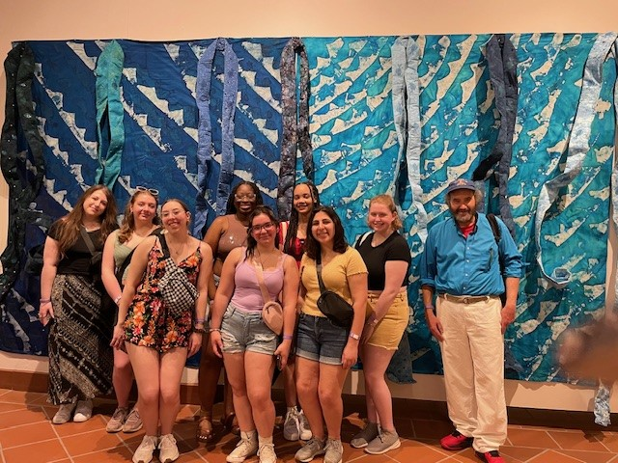

Developing Your GFC/Pre-Application Process
Getting Started
A Global Field Course shall meet the same academic requirements as courses offered on the Eastern campus, including: having a course syllabus in which the itinerary, course activities, reading list and means of evaluation are defined; scheduled meeting times; the required number of contact hours for the number of credits offered; evaluation; and submission of grades in a timely manner.
Faculty interested in developing an International Global Field Course shall begin by meeting with the Global Learning Coordinator to discuss these Guidelines and how they are implemented. Faculty shall also consult with their department chair and/or colleagues to discuss plans and obtain departmental approval for the course offering.

Determine the Travel Service Provider You Will Use
A Travel Service Provider is an organization that specializes in arranging group travel. Some partner providers specialize in group academic tours. Faculty must enter into agreements with an approved organization to facilitate arrangement of flights, lodging, meals, sightseeing side-trips, museum visits, etc. The Eastern faculty member overseeing the Global Field Course provides the academic content for the course.
Booking through a Travel Service Provider is required because it provides the following benefits:
- Advanced seat and hotel reservations are available;
- Student names are not required to initially hold seats;
- Cancellation and refund policies are more flexible;
- Built-in support should there be issues during travel;
- Partnerships with airlines to get prioritized support;
- Assistance with ensuring lowest possible price for given flights;
- Convenience of booking travel in any country in any language on behalf of the university.

Eastern's preferred provider is:
Collegiate Travel Planners (CTP)
Home - Collegiate Travel Planners (ctp-travel.com)

Other approved providers:
- International Studies Abroad (ISA)-Custom Programming
  - Faculty-Led Study Abroad Programs | WorldStrides Custom refPrograms (studiesabroad.com)
  - 1-(512)-480-8522
- Center for International Studies Abroad (CIS)
  - Custom Programs (cisabroad.com)
  - 1-(877)-617-9090
  - “The parties hereby agree to establish and mutually support a cooperative relationship, which will enable ECSU students to study abroad under the auspices of CIS Abroad's... faculty-led programs (Global Field Courses)”
  - “ECSU will receive information from CIS Abroad regarding... faculty-led programs and campus visits”
  - “ECSU students participating in CIS Abroad program will receive... on-campus pre-departure orientation for any faculty-led customized program”
- Sanditz Travel Management - (Note: Sanditz is unable to book lodging for group travel)
  - (800)-858-4456
  - Info@sanditz.com
In some cases, a specific academic travel provider might offer resources that those listed here are unable to provide. If there is a unique accommodation or learning opportunity that requires travel arrangements with another provider, then the arrangement should be discussed with the Coordinator of Global Learning for review prior to submission of the application. If the arrangement is approved, then a contract or Memorandum of Understanding must be signed by the provider and Eastern’s Vice President of Academic Affairs.
As your GFC is developed, faculty are encouraged to carefully consider the following issues and criteria and discuss them with the Global Learning Coordinator:
General Considerations
- What evidence is there of student interest for the Domestic and/or International Global Field Course (including its location and content)?
- How will the Global Field Course be marketed? What student populations will be targeted for promotional activities?
- How will the Global Field Course program fit into the range of programs already offered by Eastern? Does this program compete with or complement those existing programs?
- What will the cost be for students?
- When will the trip take place?
- What are the potential safety issues of foreign and domestic travel?
- What will you put in place to ensure the safety and well-being of the students?
- How many faculty members will be teaching the course? Bear in mind there cannot be more than 14 students per faculty member.

Cultural/Logistical Questions
- How will the Global Field Course program integrate students into the local academic and/or community lives of the country visited?
- What is the nature and degree of exposure to the host culture and language?
- How will the pre-departure materials and session(s) prepare students for the academic and intercultural experience?
- What library, computer, and research facilities are available at the Global Field Course site/s? Are these sufficient for students to complete assigned work?
- What is the nature of support services available to students on-site? Have health clinics, a hospital, the nearest consulate or embassy been identified in case there is an emergency?
- How much free time will students have and how will they be counseled to spend their free time? Will the faculty director be available after hours and on weekends?
- How will you contact students' relatives should an emergency occur?
- How will you ensure that students depart and return with you?

Academic Criteria for Domestic and International Global Field Courses
- Is the academic rigor comparable to courses offered on campus?
- Are the prerequisites clearly stated and appropriate?
- Does the course enhance or supplement, rather than duplicate on-campus curriculum?
- If this is a new course, it should be approved by the Curriculum Committee unless offered as a one-time opportunity.
- What are the intended academic goals of the program? Are these goals feasible given the program duration and the resources and facilities available to the students?
- Who is the intended audience for the Global Field Course? Does the course have a broad enough appeal (i.e., is it a general education course or a required course for majors or minors) to attract a sufficient number of participants?
- What are the academic advantages to conducting this course abroad?
- What are the advantages to the specific international or domestic site proposed?
- What are the qualifications of the faculty? Does the faculty director have prior experience in this country or region? Does the faculty director have prior experience in directing a group of students domestically or abroad? Will the program use host faculty? If so, how will they be selected? What are their qualifications? How will they be paid?
- What are the admissions requirements for the program?
- Is the projected program size conducive to an effective learning environment, given the location, facilities, and proposed activities?

Location and Time of Year
Travel to most locations can be classified as either "peak" or "off peak" depending on the time of year. The cost of travel to and within the location may change significantly depending on whether it is peak or off-peak.

Staffing
Global Field Course programs can be directed by one or more faculty members. The maximum number of students per faculty number is 14. Course caps should reflect this ratio with a maximum of 28 students enrolled if there are two instructors and a maximum of 14 students enrolled if there is one instructor. The travel costs for faculty should be equally divided across all students enrolled in the course. These costs should be reflected in the budget estimate. Allotment of FLCs can be discussed with your department chair and academic dean.
Teaching Assistants (TAs)
Teaching Assistants (TAs) are permitted to participate in Global Field Course travel, but the following guidelines must be followed:
- TAs must pay for their own travel. Fees contributed by students enrolled in the course cannot be used to fund TA meals, lodging, airfare, etc.
- TAs should not be expected to contribute to faculty travel costs. Those costs should only be borne by registered students.
- For-credit Teaching Assistantships must be approved by the appropriate Chair and Dean following the standard Internship/Independent Study/Teaching Assistant registration process. Responsibilities and evaluation criteria should be outlined in that document. Approvals for these for-credit Teaching Assistantships should be secured prior to booking travel and collecting payments from TAs.
- TAs are not counted as faculty in determining the 14:1 student to faculty ratio.
- TAs should not be expected to substitute for faculty supervision.

Itinerary Selection
Keeping in mind that more is not always better, Global Field Course proposals should make a good case for the amount of travel proposed. As travel itineraries are developed, faculty are encouraged to pay close attention to the length and complexity of the travel itinerary, keeping in mind that both will contribute to the price of the program and the likelihood of facing challenges on the ground (e.g. running behind schedule).

Itinerary Modifications
Itinerary modifications made on the basis of safety and security will be based on information provided by the U.S. Department of State often conveyed as "Travel Warnings". Faculty running the field courses, in conjunction with Global Learning, must regularly check (once a month is recommended) for travel advisories in the host location to ensure safety of faculty and students. Travel advisories can be found via the U.S. Department of State website/Smart Traveler app and you can sign up for alerts in advance of your trip here.
In the event of an emergency cancellation of travel, instructors should be prepared to adjust the syllabus as necessary so that students can earn the course credit despite the cancelled trip.

Program Credits
While the academic deans have the authority to determine the number of credits for a given travel study program, the general rule to be followed is that the number of credits to be earned should align with the requirements and assignments associated with regular semester courses.

Scheduling
The earliest departure date for summer courses abroad is the first calendar day following commencement. Travel plans should not require students to miss any regular fall or spring semester classes.

Contact Hours
A contact hour is generally defined as time spent in an activity that engages students in the learning objective(s) of the course. This can include lectures, site visits, excursions, discussions and/or student presentations. It is important to differentiate between time spent in travel status and time spent engaged in the pursuit of the academic objectives of the course. A three-credit course should require at least 45 contact hours of engaged learning.

Site visits
Site visits are critical to the objectives of a Global Field Course. Significant thought should be devoted to how site visits will be structured, when they should be scheduled, and how the students will be required to synthesize the visit with the course curriculum. Faculty should inform students of costs and payment arrangements for site visits (student pays on-site fees; faculty member pre-collects admissions fees. etc.)

Unstructured time
While it is certainly important for program participants to have some "downtime," it is recommended that faculty schedule unstructured time judiciously and carefully outline what is considered an acceptable use of the unstructured time. Too much unstructured time could cause the academic integrity of the program to be questioned. On the other hand, too little free time could lead to exhaustion or information overload.

Independent Travel
Independent travel is not encouraged. If the Global Field Course program allows for a significant span of unstructured time in which students might arrange independent travel away from the host site, it is important for faculty to take proactive steps to ensure students' safety. Faculty conducting Global Field Courses should insist on a student schedule that provides a complete itinerary of travel while the student is engaging in independent travel. Faculty should always be aware of the whereabouts of all students. Carefully outlining the geographic boundaries and insisting that students travel in pairs or small groups helps achieve this goal. Contact information and time of return from independent travel are of paramount importance.

Lodging
Many different student health and safety issues can and have arisen during Global Field Course travel. Because of this, a minimum of one faculty member should generally stay in the same lodging accommodation as all students participating in the course so that any critical situations can be addressed in person as quickly as possible. If a partnership exists in which students are housed by a host university with on-call staff personnel in the building and faculty housing in the building is not available, then nearby lodging can be considered for the instructor.
Eastern has established relationships and formal agreements with several Travel Service Providers offering varying services. These approved Travel Service Providers should be used to secure lodging for international travel to ensure that accommodations have been vetted and are determined to be sufficient for the comfort and safety of participating students. Proposals for alternate arrangements should be made via email to the Global Learning Coordinator, documenting why this arrangement is necessary for the success of the course and how the health and safety of students are being monitored.
Up to one guest may stay in faculty accommodations. If larger or additional accommodations are needed based on family members or guests joining the trip, then the guests must fund their own percentage of the lodging so that the costs are not absorbed by enrolled students. (Example: if a faculty member plus 3 guests/family members are staying in hotel accommodations, only 25% of faculty costs should be absorbed by students with the rest paid by the faculty/guests. If one additional guest is able to stay in lodging that would be sufficient for the faculty member traveling alone, then no additional cost needs to be paid). Guests should not be included on university travel paperwork. All guest payments need to be made directly to the travel provider.

Faculty Travel Costs
No more than 25% of the total student payment for a Global Field Course should be dedicated to faculty travel costs.

Faculty Compensation - Regular Semester Load Assignment
The vice president for academic affairs and/or the academic deans establish the minimum enrollment levels and load assignment for all courses, including those offered in connection with Global Field Courses. Generally, at least nine (9) students must be enrolled in a course. This number also typically applies to Global Field Courses.

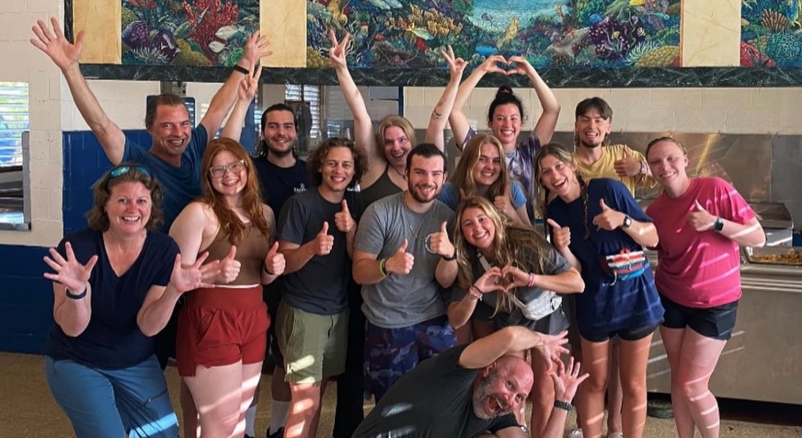

Program Proposal/Application
Once a Global Field Course program has been conceptualized, a Global Field Course Proposal form shall be developed and submitted to the Global Learning Coordinator. Then, it will be routed by Global Learning to the appropriate department chair(s), dean, and academic vice president for approval. The GFC will then be scheduled by the hosting department and advertised through the department, Global Learning, and University Relations.

Establishment of Academic Courses
The host academic department has complete authority over the academic course(s) associated with a Global Field Course. It is, therefore, the host academic department's responsibility to submit the appropriate paperwork to create the course section(s) and assign faculty load.

Budget Development
Developing the budget for each Global Field Course is one of the most critical steps in the administration of a Global Field Course program. While programs must be priced affordably for Eastern students, the student cost of the travel program must be sufficient to cover all program costs and provide a small margin for unforeseen emergencies and other costs of doing travel business, such as fluctuating exchange rates, flex pricing for lodging, and changing airline costs. Faculty travel costs (Administrative fee) must be built into the charges paid by each student. Faculty are required to submit receipts for all trip-related purchases for reimbursement. Therefore, faculty should account for tips in their budget during the planning process. A final budget must be cleared by the Global Learning Coordinator.
Enrollment/cancellation and payment deadlines will be established. In most cases, the airlines require confirmation or cancellation of space 90 days prior to departure in order to avoid cancellation penalties. The majority of student costs should be paid by the first day of classes to help solidify the class roster. For more information on payment deadlines, please review the Collecting of Revenue & Payment to Vendors (Bursar's Office) section of this document.
Teaching Assistants pay for their own travel, but do not contribute to faculty travel costs and therefore are not borne by the students.

Enrollment Targets
It should be noted that there may be two different target enrollment numbers associated with a travel study program: one being the minimum number of students required to run the travel component of the program outlined by the service provider, and the other being the minimum number of enrolled students required to ensure the academic course will run. For example, a travel service provider being used might require a minimum of 12 people for a stated price to prevail, while the academic dean may require only 9 students be enrolled in the course in order for the faculty to get full credit/pay for the course.

Consistent with article 5.17.2 of the AAUP collective bargaining agreement, "class size limits shall be determined on sound education principles by the appropriate academic dean in consultation with the department or interdisciplinary program." The faculty member(s) leading the Global Field Course is/are responsible for contacting the dean's office to determine the minimum number of enrolled students required to run the academic course(s) associated with the Global Field Course program. In general, academic courses are required to have at least nine students enrolled in order to run.

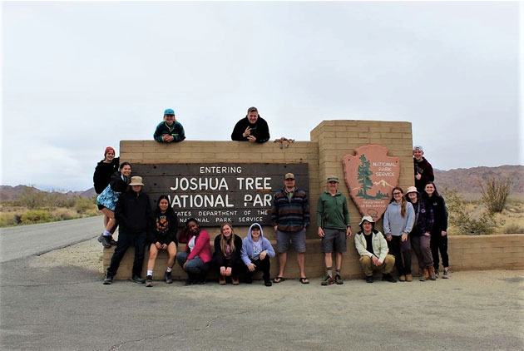

Post-Application/Program Approval
Course Tuition and Fees
Students register for the course associated with the Global Field Course once they gain approval from the lead faculty. A series of forms are required to be approved for the travel component. The links for these forms can be found on the Faculty Resources for Global Field Courses webpage. All tuition and fees are payable to Eastern Connecticut State University.

Scholarships
Scholarships may be available to students on a need-based basis. Scholarship allocations are determined by Global Learning. Students who receive the scholarships will be expected to complete a Commitment Form for the course, register for the course before the spring semester, and pay for the first trip deposit on their own. The scholarships will be deposited into the corresponding trip budget for each student and deducted from the last payment required for the trip.
Departmental scholarships provided via the ECSU Foundation will be applied to accounts only following the travel component of the trip.

Developing a Promotional Flyer
The promotional materials used for Global Field Course programs are legally binding and care should be taken when they are developed. Faculty conducting Global Field Courses are encouraged to develop a one-page flyer suitable for posting both on university bulletin boards, electronically at various web sites, or as an attachment to e-mail requests from students for information. At minimum, the following information must be included in any materials used for Global Field Course promotion:
- Program dates and destination(s);
- Estimated program price, description of services included in the price, and minimum number of participants required for that price for the course to run;
- The academic courses associated with the program (course title, number of academic credits, and any prerequisites);
- Course objectives/narrative description of the academic requirements of the program
- Deadline for student application;
- Contact person organizing and conducting the Global Field Course
Global Learning will develop its own promotional materials that will be shared with faculty/departments for marketing.

Additional Promotional Methods
The most successful methods of promoting a Global Field Course are classroom announcements and one-on-one discussions. Faculty are encouraged to repeatedly announce their Global Field Course in their classes and to ask colleagues to announce the opportunity as well.
Individual Global Field Course brochures may be developed and printed by the sponsoring faculty/academic departments at their own expense. In addition to the promotional materials described above, faculty are encouraged to make use of the following media to promote all Global Field Courses:
- A press release to local media through the Office of University Relations;
- Announcement on the GFC website;
- Announcement in the Student Newspaper;
- Announcement at public venues at the university;
- Participation in information sessions sponsored by the Global Learning Office.

Developing A Timeline for Students
It is important that faculty conducting Global Field Courses develop a timeline for students to follow. Some timeline items are set by Global Learning. If faculty see reason to adjust the pre-set timeline, faculty must discuss with the Global Learning Coordinator. The timeline faculty should share with students may include but is not limited to the following:
- Deadline for application
- Deadline for initial payment
- Deadline to obtain a passport (if abroad)
- Deadline to obtain required inoculations (if abroad)
- Dates for pre-departure lectures and/or orientation
- Due dates for student papers relating to Global Field Course
- Deadline to register for the course associated with Global Field Course
- Deadline to pay for the course
- Deadline for remainder of payment for Global Field Course

Student Application and Enrollment Policy
Eastern Connecticut State University is committed to a policy of non-discrimination, equal opportunity and affirmative action for all persons regardless of race, color, religion, sex, sexual orientation, age, national origin, marital or veteran status or disability. This policy is applicable to all employment practices, admission of students, programs and services to students, faculty, staff and the community. This policy is equally applicable to off­ campus programs sponsored by Eastern, such as Global Field Courses.

Accommodation
Persons with a disability who desire to participate in a Global Field Course and who require accommodation should provide appropriate documentation to the faculty organizing the Global Field Course as soon as possible so that the availability and feasibility of accommodation abroad can be evaluated.

Student Application Process
Students apply to participate in a Global Field Course by contacting the lead faculty member. Faculty are strongly encouraged to collect student interest through an online form. The Global Learning Office will provide this template. It is the faculty member's responsibility to determine if the applicant qualifies for the Global Field Course by meeting all prerequisites. For final approval, students must complete a Global Field Course Student Commitment Form and all associated medical and liability forms. All forms can be obtained from Global Learning.

Enrollment Process - Academic Courses
Students must be approved by the lead faculty member to be registered for a Global Field Course. The department should consider placing prerequisites and/or registration restrictions as needed. In addition to faculty approval, students must submit the Commitment Form and Student Conduct Form before becoming eligible to participate in the course.
The basis upon which a student may be denied enrollment in a Global Field Course program includes, but is not limited to, failure to maintain good academic standing, inadequate course prerequisites, or evidence of pending or resolved judicial proceedings.

Non-degree Student Enrollment/Participation
Eastern faculty receive frequent requests from non-students (i.e., spouse or friend of an enrolled student or participating faculty member) to participate in a Global Field Course program without enrolling in the academic coursework. Such enrollment is permitted on a space available basis and requires the permission of the faculty member(s) leading the program. Guests of the program must complete all required authorization and release forms and pay all costs associated with participation in the Global Field Course program. In the case of family members accompanying faculty on Global Field Course programs, it is noted that this should not interfere with the faculty member's ability to fulfill all responsibilities associated with the program. In general, Eastern shall not admit any participants under age 16, unless accompanied by a parent or legal guardian.

Collecting of Revenue & Payment to Vendors (Bursar's Office)
It is the faculty member's responsibility to coordinate with the Global Learning Coordinator and the Travel Office in Fiscal Affairs to pay vendor invoices. Under no circumstance should faculty use personal banking/checking accounts to collect, deposit, or pay vendors relating to Global Field Courses.
All checks and/or money orders from participants are payable to Eastern Connecticut State University. Students are responsible for depositing funds into the trip budget using approved Bursar deposit methods. Charges are not added to student accounts in the same way that tuition and fees are billed. Students must pay via check with a deposit slip provided by Global Learning at the Bursar’s office. Trip budgets, including information on deposits paid and travel payments charged, can be found in the WebFocus reporting tool under the Global Learning coordinator’s name in the “Budget Reports” section. The academic department must track these payments through WebFocus Budget reporting. Additional guidance on this process can be given by Global Learning if needed.
The first deposit should be a minimum of 20% of the total trip cost and be collected in December for spring semester courses. The failure of students to pay the first deposit by the deadline should result in the dropping of the course. The deposit schedule needs to be finalized by mid-November so students can have advance notice to prepare for payment via check at the Bursar’s office. This schedule should be discussed with the Global Learning coordinator to ensure information can be posted online. It is recommended that a total of three deposits be collected for all trips.
The following payment deadlines are strongly recommended to solidify course rosters prior to winter break and finalize participation commitments ahead of the spring semester.
- Payment one: December 1 or following business day if December 1 falls on a weekend or holiday
- Payment two: January 15, or following business day if January 15 falls on a weekend or holiday
- Payment three: February 15, or following business day if February 15 falls on a weekend or holiday

Cancellation by Eastern due to Low Enrollment
The decision to offer the course section relating to the Global Field Course is the academic dean's responsibility, working with the academic department and Global Learning. The decision to run or cancel the Global Field Course program based on enrollment levels rests with the academic dean and Global Learning consistent with the cancellation/penalty date(s) established by the travel service providers being used for the program. Therefore, close communication between the faculty members conducting the GFC and Global Learning is critical. Because all students enrolled in the travel program must also enroll in the corresponding academic course(s), and the enrollment deadline for the travel program will likely occur in advance of the Registrar’s add/drop deadline, travel program enrollments determined by the travel service provider may be used as a leading indicator to determine sufficient course enrollments. The faculty member is responsible for setting enrollment and cancellation deadlines with their Dean and Global Learning and informing students of these deadlines.
If the actual enrollment is less than anticipated and higher than the minimum number required by the travel service providers being used, the appropriate dean will meet with the faculty member(s) leading the program and the Global Learning Coordinator to discuss possible solutions to covering the shortfall that the lower-than-anticipated enrollment has caused. Included among the options to be explored are faculty providing part of their own travel costs; decreasing the level of services provided and/or increasing the cost per student by the amount necessary to cover the shortfall. If an agreement is reached, modifications to the program will be made and students will be notified of modifications (if modifications are significant, students will also be required to sign an agreement acknowledging the changes), and student enrollments re-confirmed in light of the changes made.
If the actual enrollment is less than the anticipated enrollment and lower than the minimum number required by the travel service providers being used, the travel program will be cancelled for lack of enrollment.

Course Offering
Pre-Departure Orientation Programs
It is expected that the faculty conducting Global Field Courses hold several group meetings prior to departure to review specific program objectives, academic requirements, and share additional information relating to the academic course(s) and destination(s) to be visited. At these class meetings, faculty will review risk factors relating to their Global Field Course.

Global Learning Participant Release Checklist
Once students have decided to participate in a Global Field Course, they will complete several forms intended to advise them of the risks inherent in travel and to document their ability to travel. Each form is linked on the student Participant Release Checklist. Individualized checklists are sent to students from Global Learning. Students will be expected to complete most of the checklist during the semester, however, the Commitment Form and Student Conduct Form are required before the first class. Faculty members will be given access to information students share about accessibility, allergies, etc.
Students should be submitting their deposits based on the pre-set deposit deadlines (tentatively 12/1, 1/15, 2/15) while completing their checklist.

Student Costs
It is important for students to be aware of the costs associated with a Global Field Course. The costs may include but are not limited to the following:
- Airfare (at time of initiating the program-expect fluctuations)
- Tuition/fees for the academic course
- Travel and health insurance costs: medical insurance, trip delay and interruption, medical evacuation, and repatriation of remains coverage
- Land/sea travel (bus to-from airports; tour bus in country; taxis; trains; boat/ferry travel; etc.)
- Group meals
- Lodging
- Tickets (museums/exhibitions/concerts/etc.)
- Incidental costs (food, souvenirs)
- Administrative fee (which covers the cost of Faculty travel and expenses)
- Baggage fees

Payments by Students
It is important for students to know how payments should be made for the Global Field Course. All payments related to the travel (airfare, hotel, meals, etc.) must be made by the student to the Bursar’s office using approved Bursar deposit methods. All checks are to be made payable to Eastern. Global Learning will help monitor these payments, but it is the faculty member's responsibility to ensure that all students are being timely with their payments.
If trip costs are lower than budgeted, enough to warrant a refund, refunds should be issued following the conclusion of travel. Refunds should be issued if the student has overpaid by $50 or more
Faculty Use of the Eastern Travel Account
To faculty conducting Global Field Courses: All disbursements for travel are issued through Accounts Payable to the various vendors supporting the Global Field Course program. Withdrawals from the specific Travel Code Index may include but are not limited to payment for the following:
- Airfare
- Bus transportation to-from airport
- Tuition/fees
- Land/sea travel
- Pre-arranged group meals
- Lodging
- Tickets (museums/exhibitions/ concerts, etc.)
- Stipends for guest lecturers
Advances may be requested for a portion of the faculty per diem and for expenses that must be paid during group travel (activities that can’t be pre-paid prior to travel).

Termination of Participation in a Global Field Course
It is possible that it will become necessary to terminate a student's participation in a Global Field Course program once the course has started. All students are informed of the termination clause on the Health and Safety agreement. Incidents that may warrant a student's termination from the Global Field Course program may include, but are not limited to:
- Violations of the laws of the host site;
- Acts considered to be harmful to themselves or others;
- Acts likely to be offensive to the host, or offensive to others;
- Failure to observe satisfactory academic or professional standards;
- Physical or mental incapacitation;
- Engaging in unauthorized activities inconsistent with the purpose and best interest of the program.
Faculty who consider terminating a student's enrollment in a Global Field Course program are requested to confer by telephone or email with their academic dean, Global Learning, and Eastern's Director of Student Conduct. Caution should be taken to ensure that due process is afforded to students in all instances.
Once dismissed from a Global Field Course, the student loses access to all group travel arrangements that have been made for the course, except for the return airline ticket. Arrangements should be made for the student to immediately return to their home. If the student is not agreeable, they are informed that they have lost access to all group travel arrangements for the duration of the program, and is responsible for their own arrangements/actions until returning to the U.S. In all cases Eastern's administration must be informed of the circumstances surrounding the decision.

Cancellation by Eastern due to Safety Concerns
The Vice President for Academic Affairs in consultation with the appropriate dean, Global Learning Coordinator, and faculty member may decide to either re-route or cancel a Global Field Course program if an international destination location is determined to be unsafe for student and faculty travel. Resources to be used in monitoring situations and formulating recommendations include the Consular Information Sheets, Travel Advisories, and Travel Warnings issues by the U.S. Department of State, newspaper reports, and independent travel advisory companies.
If Eastern cancels a program because of safety concerns, students will be provided a full refund of all travel and course fees paid and any cancellation penalties imposed by travel service providers will be absorbed by the University, however students are encouraged to buy travel insurance to help cover trip delays/interruptions. Students traveling internationally must purchase CISI (Cultural Insurance Services International) insurance coverage that includes medical and security evacuation, accident and sickness coverage, and repatriation of remains coverage. If Eastern cancels their program due to safety concerns, students can be granted a full refund for their CISI coverage so long as the policy date has not surpassed.

In case of emergency trip cancellation, instructors should be prepared to adjust the syllabus as needed.

Withdrawal by Students from Travel Program
If a student must withdraw from a Global Field Course program, they must do so in writing via email to the faculty member organizing the Global Field Course as soon as such a decision is made. The University will hold the student financially responsible for all cancellation penalties imposed by travel service providers, which may be as high as the full cost of the program.

Cancellation/Withdrawal by Students - Academic Course(s) Associated with a Global Field Course
The normal University course withdrawal policies for full and part-time students apply to the academic courses associated with all Global Field Course programs. Students seeking withdrawal from the course associated with a Global Field Course program should be referred to Global Learning.



Travel
Transportation to-from airport
It is the faculty member's responsibility to advise students of procedures relating to transportation to-from airports. It is often appropriate to have the participants meet at the departure airport at a time specified by the airline. Faculty may, however, arrange for bus transportation from Eastern and to-from the airport. If so, the cost for bus transportation to-from the airport should be calculated into the expenses for each of the participants in the Global Field Course.

While Abroad
- Confirm the group’s safe arrival with the Global Learning Office by email within the first 24 hours.
- Accompany students on all program activities.
- Teach the course and coordinate with any overseas staff/lecturers.
- Act as Resident Director in charge of the overall well-being of students.
- Resolve any housing issues that may arise on-site.
- Inform Global Learning immediately of any serious health related or disciplinary issues.
- Supervise excursions, making additional arrangements if necessary.
- Hold regular office hours/meeting times with students.

Roommate Assignments
Roommate assignments for Global Field Courses are done following the practices of Eastern’s Housing office. Roommates are grouped based on assigned-at-birth sex unless specific alternate arrangements are requested and agreed upon by the students enrolled in the course.

Faculty are encouraged to survey students on lodging arrangements using the template found here.

Faculty Travel Support
Faculty travel costs will be amortized across the number of students participating in the Global Field Course. The trip budget must clearly break down the base student cost and what percentage of student cost is paying for faculty travel.
A Travel Authorization Form (TA) must be prepared for all faculty conducting a Global Field Course program to document the trip as official university business, as well as to provide a vehicle through which faculty may be reimbursed for authorized travel expenses paid out-of-pocket and for paying vendor invoices. The faculty is responsible for routing the document through the normal university channels (Adobe) to secure the required signatures. All travel authorizations should be fully signed prior to the class start date. The Global Learning Coordinator is included as a signer. The TA should include the form, a list of all enrolled students, the course itinerary, the trip budget, and confirmation of lodging/airfare estimates by a travel service provider. Guests should never be included on TA paperwork.

Risk Management
Faculty Concerns
Faculty shall assume responsibility for students when leading a Global Field Course. There is a "duty of care" imposed upon faculty who conduct these programs. Examples of duty of care include: ensuring students receive proper medical treatment should they become ill or injured; exercising due diligence to ensure students maintain group standards; and, generally speaking, being knowledgeable about the destinations to be visited and the travel service providers being used.
In practice faculty should, at minimum:
- be familiar with the students' medical conditions as disclosed by the students on the Global Learning Health and Safety Agreement provided to each faculty member;
- be knowledgeable about the means of requesting emergency medical treatment in the host country;
- be informed about the emergency services provided by U.S. Consulates and Embassies abroad;
- carefully define "class time" and "free time" on the program itinerary and set in writing the parameters on how "free time" may be used (define acceptable geographic radius students may travel, require students to inform faculty what they have planned for their "free time," encourage use of the "buddy system" when traveling outside the group, require students to always have the hotel telephone number with them, etc.);
- inform students of risks when touring cities, towns, or visiting hosting universities;
- inform students that they must sign the Statement of Responsibility, Release, Indemnification, and Authorization as part of the Global Learning Health and Safety Agreement.
Faculty conducting Global Field Course programs should be aware of the potential for issues to occur while traveling. Whether perceived or real, these problems must be addressed appropriately and in a timely manner. Faculty members should review the Emergency Playbook before traveling and have the document easily accessible while away. The Emergency Playbook includes what to do in emergency situations and contact information for anyone who should be informed.
All medical emergencies that occur during a Global Field Course program must be reported to the Eastern administration as soon as possible following the occurrence. Prior to departure, each faculty member will be provided with the appropriate contract information for Administrators.
In the event of an emergency during a Global Field Course program resulting in a claim of liability, the faculty may be indemnified by the State of Connecticut Attorney General's Office in ensuing legal affairs so long as they have not been negligent in their duties. (See Connecticut General Statutes §4-165 and §5-141d).

Student Concerns
Through the Health and Safety Agreement (a required form on the Participant Release Form), the office will obtain health and emergency contact information from them to be used in a medical or other emergency. Faculty members will be given access to information students share about accessibility, allergies, etc. in case of emergencies while traveling.

Faculty: Medical Concerns
Faculty are encouraged to contact their health insurance provider prior to embarking on a Global Field Course program to learn about the carrier's provisions for overseas care and the procedures to be followed should medical treatment become necessary (if international travel). Faculty have the option to purchase emergency medical treatment insurance through CISI.
Injuries sustained during a Global Field Course program may fall under the State of Connecticut Workers' Compensation Plan. Should an injury occur, faculty should keep a written record of the details including the date, time and circumstances of the accident, as well as the names and contact information of any witnesses. Medical emergencies must be reported to the Eastern administration (via police department) as soon as possible. All medical bills should be retained. Complete information on the Workers' Compensation Plan is available in Eastern's Human Resources Office.

Students: Medical Concerns
The University requires all students participating in international Global Field Courses to be covered by CISI (Cultural Insurance Services International) medical insurance. Students receive a link to purchase the CISI coverage specific to Eastern at a discounted rate. Students and GFC instructors are provided details about the insurance plan to understand its coverage. If a Travel Service Provider offers similar insurance, the Global Learning coordinator will review the plans for a potential waiver of the CISI requirement.
Additionally, students are asked about medical conditions on the Global Learning Health and Safety Agreement. Instructors of the GFC are given access to a secure Teams folder with the Health and Safety forms students complete in case of medical emergencies while on the trip. Both the Health and Safety Agreement and Global Learning staff strongly encourage students to consult with their doctors about the GFC travel component profior to the trip.

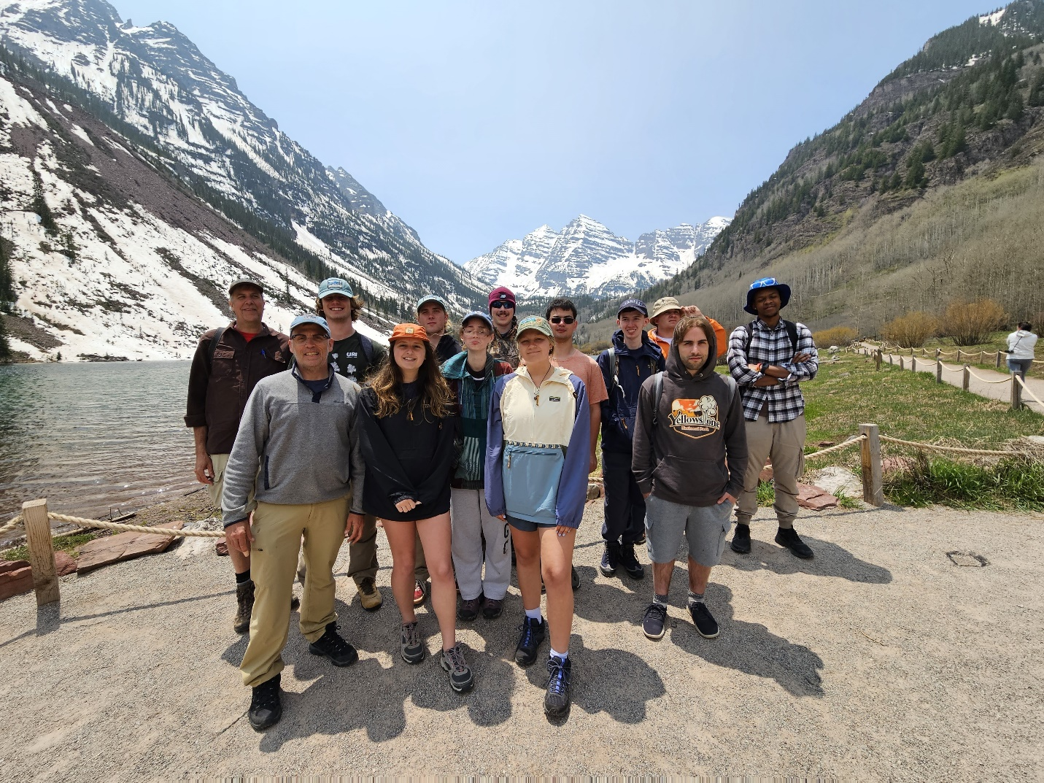

Post-Course/Travel
Post-Program Student Survey
The sponsoring academic department's Departmental Evaluation Committee may wish to evaluate the academic courses offered during the Global Field Course program as part of their standard departmental course evaluation process. The survey can be found here.

Academic Credit
For GFCs with summer/winter travel, faculty must submit grades upon return to replace the “Incomplete” granted to students at the conclusion of the Spring/Fall semester. This should be done as soon as possible following completion of coursework to prevent student issues with class standing, prerequisites for registration, etc.



Appendix
Planning Resources When Traveling Out of the Country

Safety:
http://www.travel.state.gov/
This official site of the U.S. Department of State' Bureau of Consular Affairs contains up-to-date information on the general, economic, medical, and other conditions in most countries of the world and, when necessary, provides guidance on areas to be cautious of or avoided altogether. Specific links available through this site include Travel Warnings and Consular Information Sheets, a List of Current Warnings and Public Announcements, and Travel Publications, including such documents as A Safe Trip Abroad, Tips for Students, and U.S. Consulates Help Americans Abroad.
SAFETI - SAFETI (Safety Abroad First - Educational Travel Information) (globaled.us)
The SAFETI (Safety Abroad First - Educational Travel Information) Clearinghouse Project is funded by FIPSE (the Fund for the Improvement of Postsecondary Education) of the US Department of Education. Lt is a part of the Center for Global Education at the University of Southern California and provides a well-organized database of articles and policies, largely adopted from the Peace Corps Pre­departure Handbook.

Health:
http://www.cdc.gov/travel/
The Center for Disease Control's Travelers' Health section provides general information on health concerns associated with regions of the world and on the immunizations required to visit certain countries or regions. While it is always best for travelers to check with their personal physicians before traveling, this site does offer good general information.
https://www.who.int/travel-advice
The World Health Organization's International Travel and Health site.

Itinerary Planning:
https://www.ccsu.edu/studyAbroad/semestersAbroad/index.html
CCSU has an extensive network of partner universities abroad. Using a partner university as a "home base" for a Global Field Course can be cost effective and, at the same time, strengthen the partnership by providing opportunities for faculty and students from both universities to interact in an academic setting.
http://www.lonelyplanet.com/destinations/
Lonely Planet's Destination site offers a user- friendly search engine for quick access to detailed destination guides, complete with maps, for hundreds of countries and cities worldwide.
https://www.worldtravelguide.net/country-guides/
World Travel Guide's detailed country descriptions, including business profiles, climate information, and maps.

In addition to these web resources, Eastern faculty who have led International Global Field Courses in the past are an excellent source of information. Contact the Global Learning Coordinator to connect with relevant colleagues.

