How to Enter a PSA Request in Cobblestone Contract Management

Log in to Cobblestone
- Go Eastern CT website; select Faculty Staff; Select Campus Resources, Select Purchasing
- Select Contract/PSA Request – The Cobblestone Template Should Open
- 
- Sign in using your Eastern credentials if prompted
- This will bring up a screen: My Dashboard

Access the Contract Request Form
From the Main Menu, select Add Request You will move to the Add a New Request Record Screen
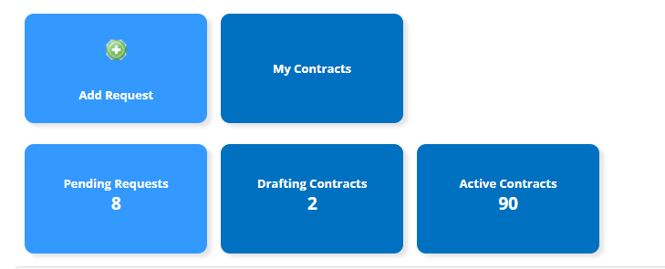

Select PSA as the type of Request you are making- from the drop-down menu:
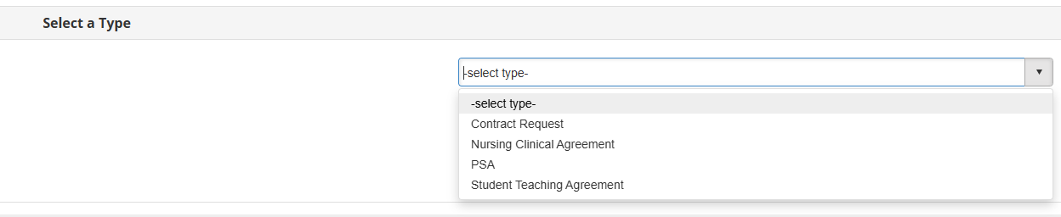
Click Continue
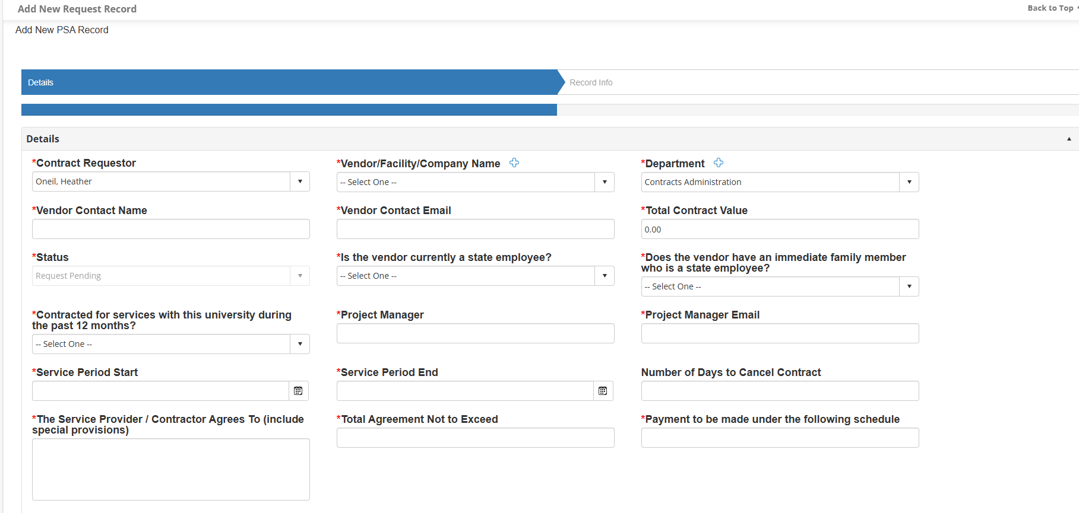
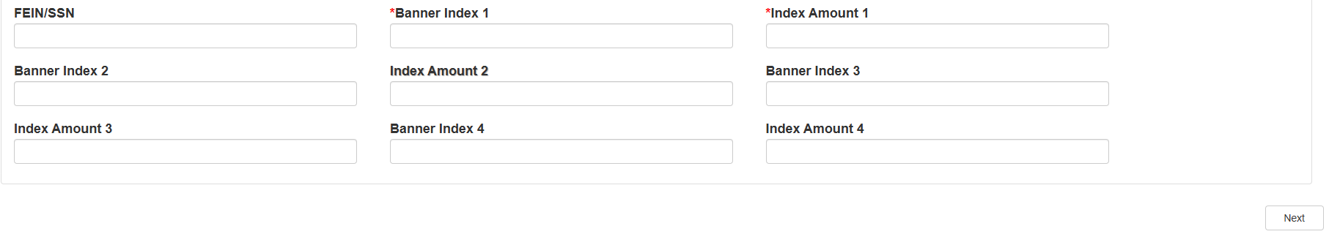

Fill in PSA Details
Contract Requestor: Your name—If it is another employee you can add them manually
Vendor/Facility Name/Company Name: Company Name
If the vendor is not in the list—select “New Vendor Not in List” Two new boxes will open where you can enter the new vendor’s name
Vendor Contact Name: Fill in the name of the person who you will work with
Vendor Email: Contact Email
Department: Select your department
Contract Value: Amount of Contract
Status: is prepopulated
Is the vendor currently a state employee? Select Yes or No
Does the vendor have an immediate family member who is a state employee? Select Yes or No
Contracted for services with this university during the past 12 months? Select Yes or No
Project Manager: Eastern employee who will be overseeing these services
Project Manager Email: Email of Eastern employee who will be overseeing these services
Service Period Start: Date the services will begin
Service Period Start: Date the services will end
The Service Provider/Contractor Agrees to (include special provisions): Enter services they will be provided, when the services will start, time of services, etc.. Example: John Smith will be a guest speaker during the Music Departments Colloquium on February 6, 2026 from 1pm-3:30pm in the Betty Tipton Room at Eastern CT State University.
Total Agreement Not to exceed: Dollar Value of Services
Payment to be made under the following Schedule: How is the vendor requesting payment Is it monthly, quarterly, after project completed etc.
Banner Index 1: Enter the banner index that will be charged for this services. Example: PART03
Banner Index Amount 1: Enter the dollar about to be charge to this banner index. Example: $100
If you have more than one banner index, please fill in the Banner Index 2 and Banner Index Amount 2, then Banner Index 3 and Banner Index Amount 3, etc..
Hit the NEXT Button
The following screen is just a review screen, there is nothing you need to fill out, just
Hit the FINISH Button
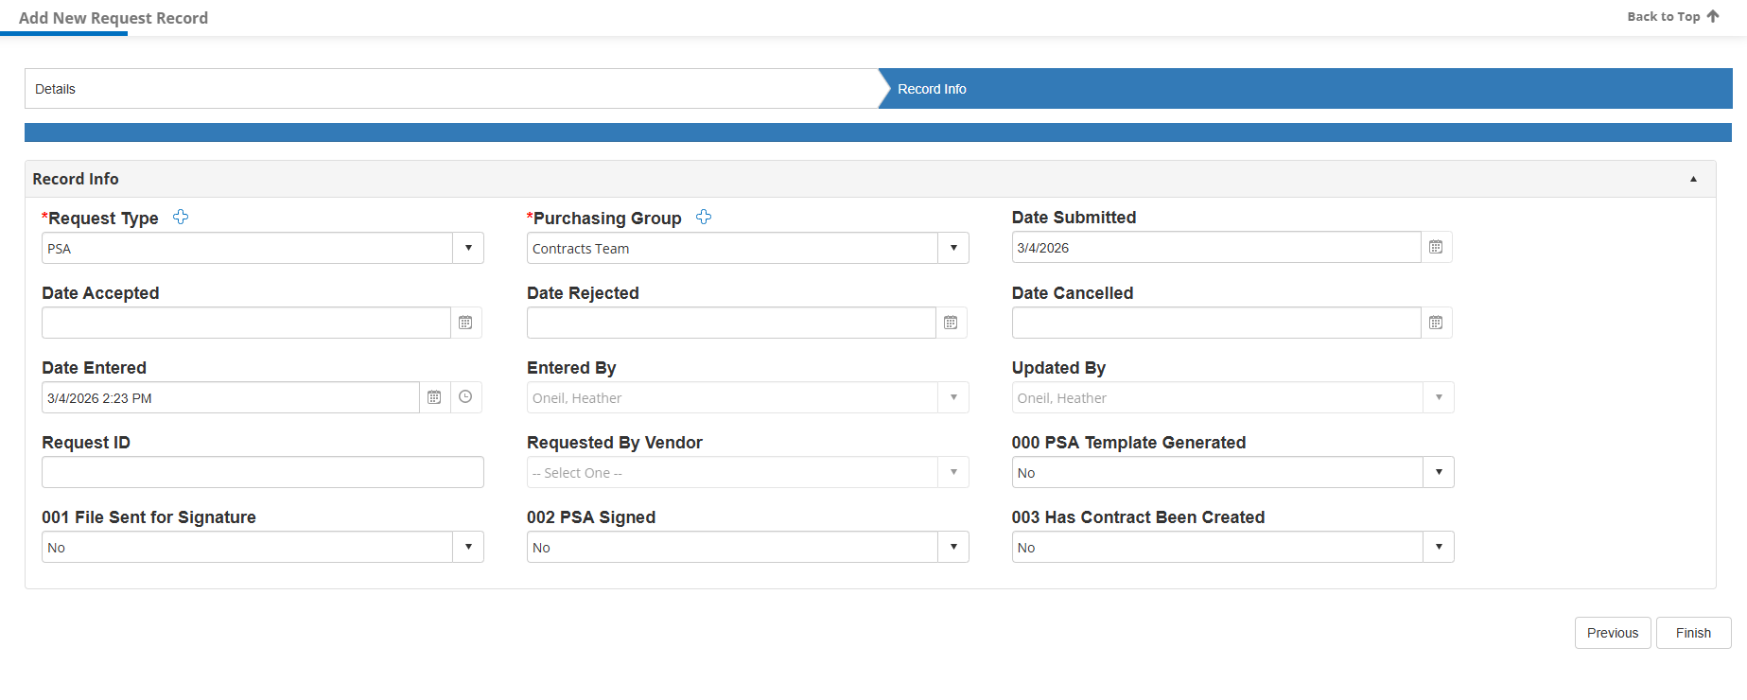
The next screen is a review of all the details you entered for the request
Tab 1 Record Details – Review. If you need to edit just click the pencil icon
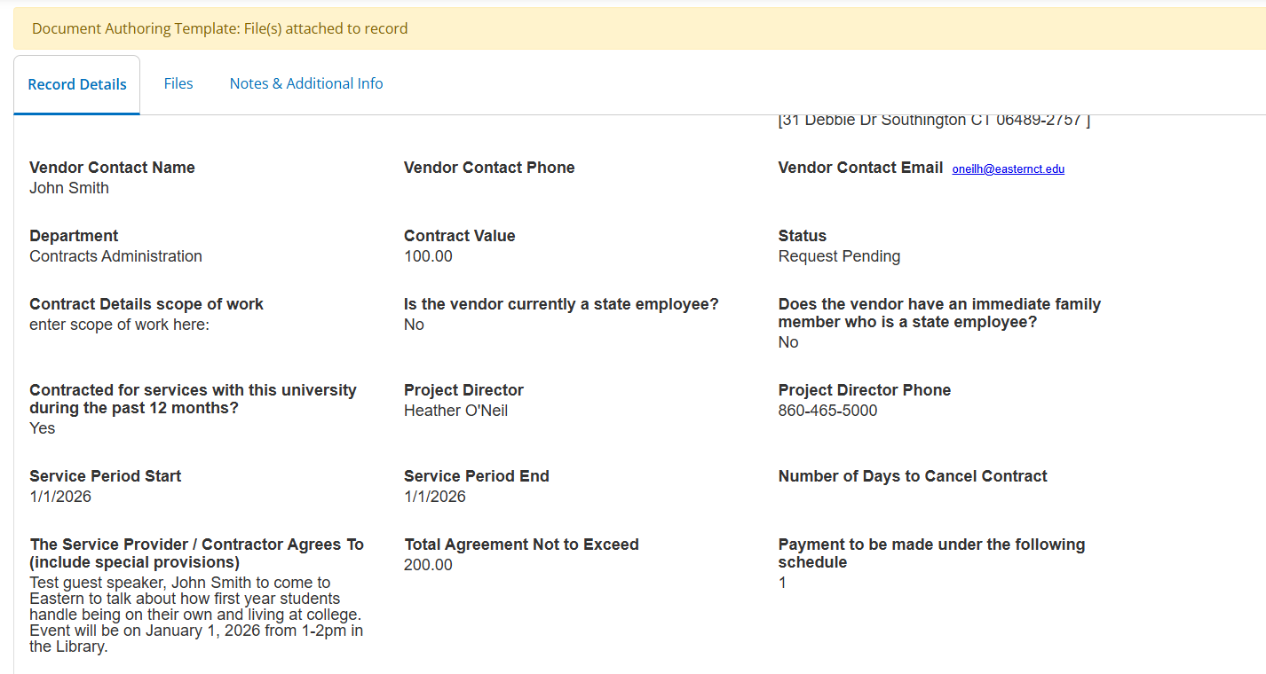
Click Tab 2: Taske & Attachments
Section 1
File Category: select Internal
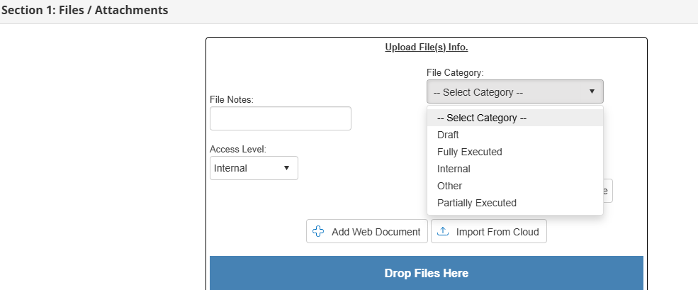
Attach all relevant documentation, ex. W9, Scope of Work, Quote, minutes, insurance, etc.
The PSA will automatically generate and will be named PSA-under 5000.docx (this could take up to 5 minutes to upload)
NEXT STEP: SIGNING THE DOCUEMNT
Click on the toolbox icon
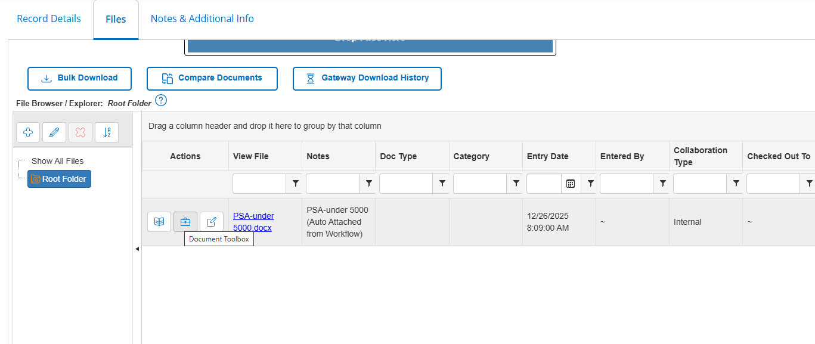

Select the Esign Document button
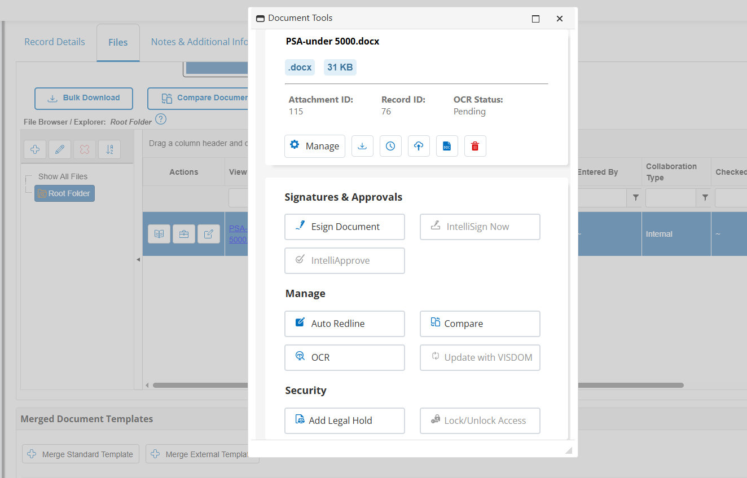

Select the either DocuSign or Adobe Acrobat Sign button
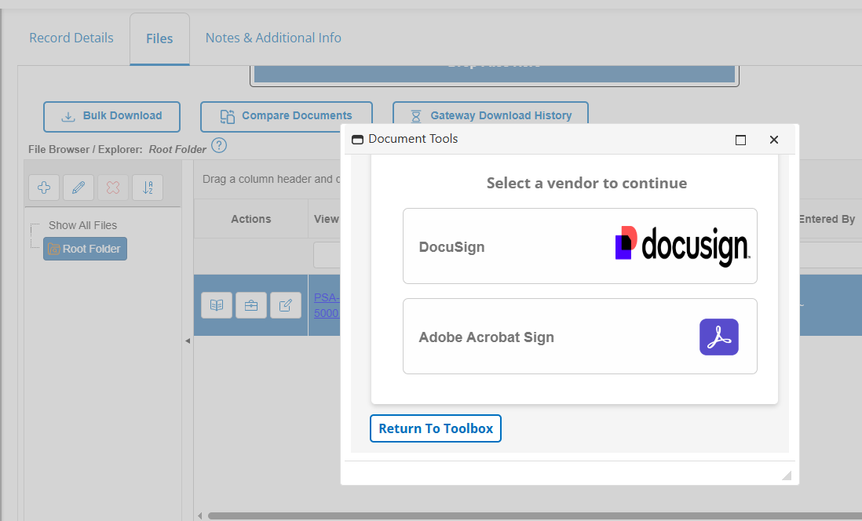
Select the NEXT button
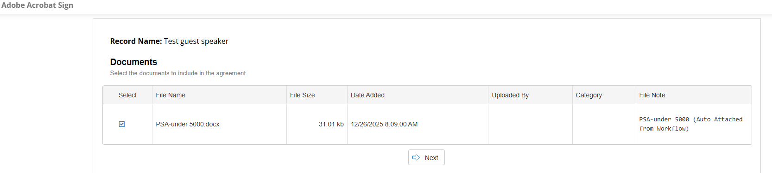
Enter the email addresses that you would like to send for signature (list them in the order they are to be signed), the agreement Title and any message. Then Select SUBMIT Button.
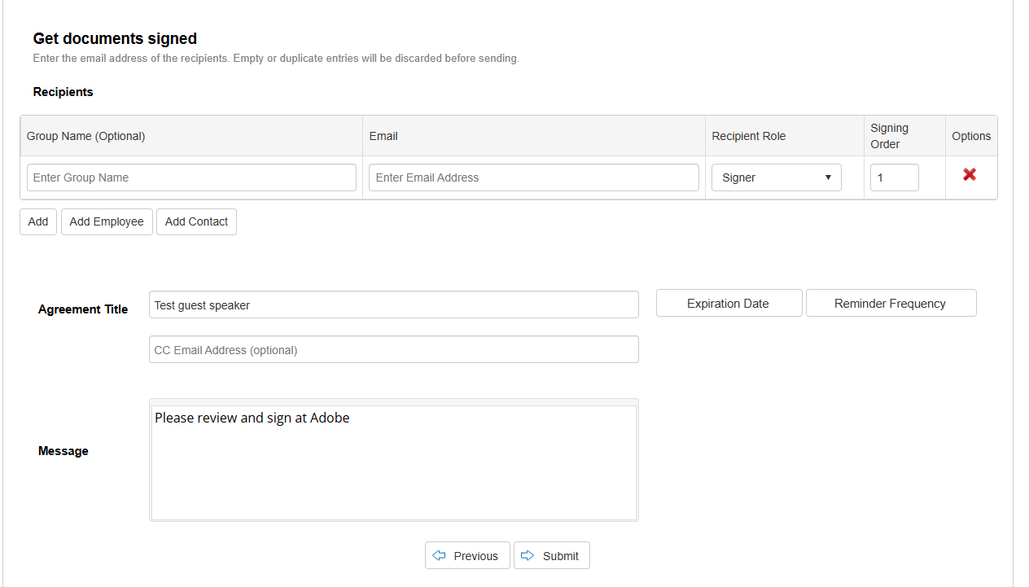
Select the OK button to begin the upload process
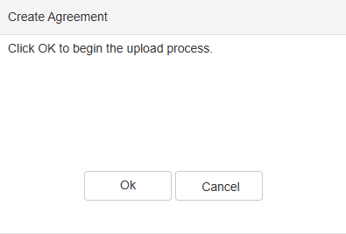

Select the COMPLETE button to be redirected to Adobe Acrobat Sign or Docusign to complete and send the Agreement.
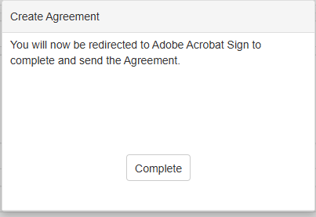

- Select the vendor’s name and place the e-sign , title and date in the SERVICE PROVIDER Section of the PSA.
- Select the department’s Dean name and place the e-sign , title and date in the APPROPRIATE DEAN Section of the PSA.
- Select the department’s VP name and place the e-sign , title and date in the VP-EASTERN Section of the PSA.
- Select the department’s budget authority to sign for the banner dollar amount and banner index and place the e-sign next to the banner indexes (only needed if signing authority is needed for multiple departments.)
- On page 4 of the PSA Template insert a field so the vendor can place their initials next to the nondiscrimination box.
- On page 1 of the PSA Template have the SERVICE PROVIDER initial next to lines 3, 4 & 5 to verify these questions are correct.

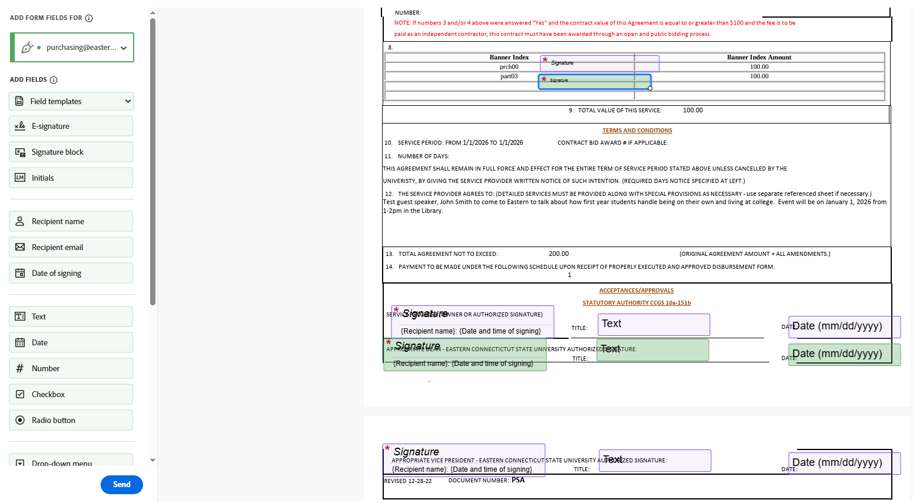
Select the SEND button
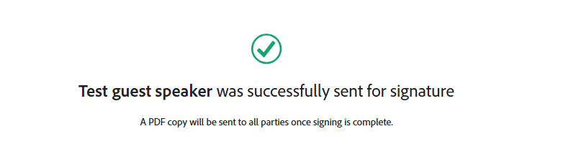
Document has now been sent for signatures.
The requestor will receive emails via adobe sign or docusign and the requestor can also see this in Cobblestone.
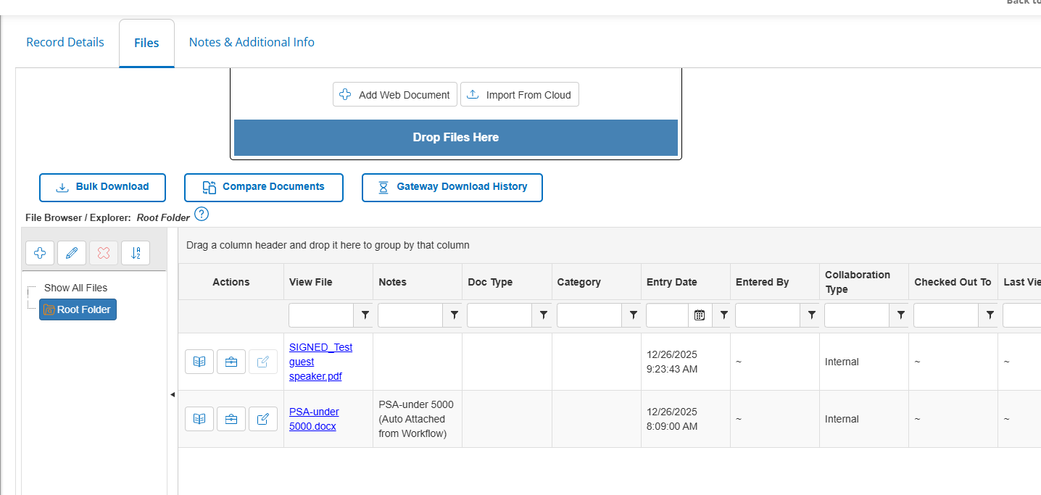
Once the PSA is signed by all parties, the purchasing department will be notified through cobblestone. The PSA will be reviewed to verify that all documentation is complete and compliant with applicable requirements. Upon completion of this review, a purchase order will be issued in banner and emailed to the Vendor and Project Manager.

